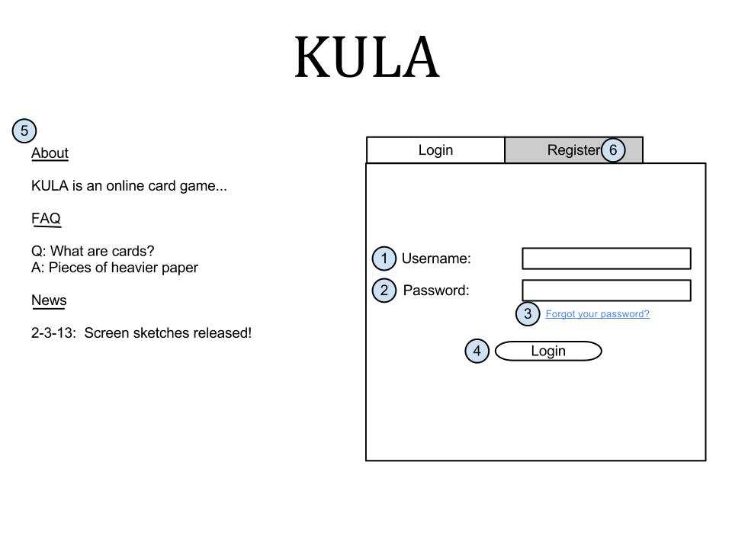This screen is shown when the user first opens the website, assuming they’re not already logged in. From here they can log in to access the card games, or review some of the information on this screen.

Login Screen – Trevor Lund

Everything about the screen is pretty standard as far as login screens go. There are boxes to fill in your username (1) and password (2), as well as a link in case you forgot your password (3). There is also the button that submits your information and allows you to log into the game itself (4). If you don’t have an account, you can click on the “Register” tab (6) to go to the register screen. Finally there is the information panel (5), containing information about the game, FAQ, and updates or announcements about the game.